**L05 Assignment – SVM for Image Classification**

**Activities:**

* I implemented a Support Vector Machine (SVM) for image classification using the CIFAR-10 dataset.
* I preprocessed images by converting them to grayscale and flattening.
* I trained an SVM classifier and evaluated its performance.

**Results:**

* I achieved a classification accuracy of 21.4%.
* I observed low precision, recall, and F1-scores across all classes.

**Reflection:**

* **Challenges**: One of the biggest challenges was the low model performance and scalability issues with large datasets.
* **Solutions**: I recognized the need for better preprocessing and feature extraction in order to work with low computational resources.
* **Key Takeaways**: I gained insights into the strengths and limitations of SVMs for image classification.

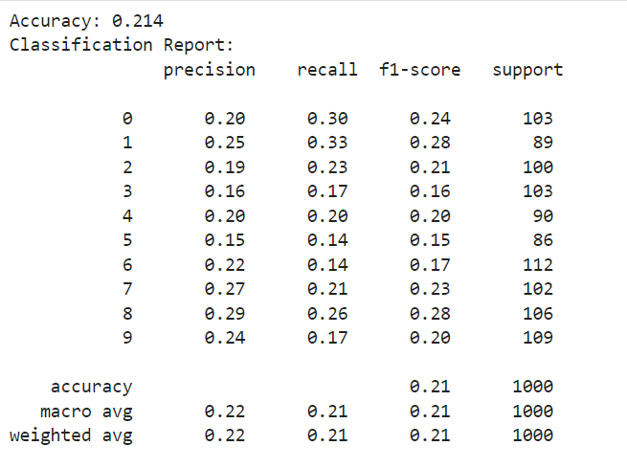

Results from SVM Classifier using CIFAR-10 dataset